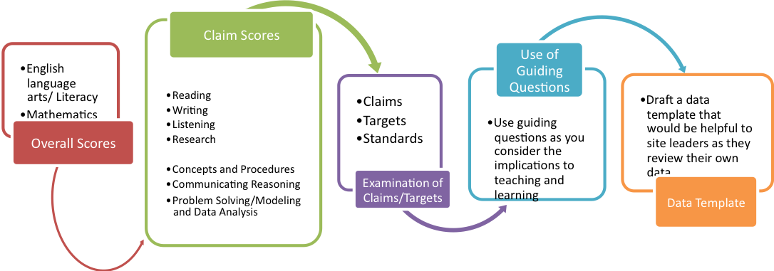

Available Tools
- Smarter Threshold Scale Scores
- Achievement Level Bands
- Threshold Achievement Level Descriptors
- Summative Assessment Blueprints
- Claims Alignment Documents (Riverside COE, Smarter Balanced)
- Data Sheets
  - Overall Summative
  - Claim Scores
- Examples of templates
- Guiding questions
- Colleagues
Beginning the Process
- Use the data as an entry point into the curriculum, instruction and assessment cycle
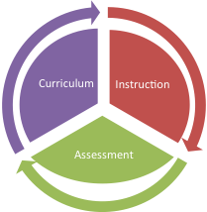

Managing the Data
Below are the ELA and mathematics achievement level ranges and threshold cut scores (in bold); they can be used in making data observations about overall scores.
English language arts/literacy
Grade | Level 1 |  | Level 2 |  |  |  | Level 3 |  |  | Level 4
Grade | Equal to or Below |  | From |  | To |  | From |  | To | Equal to or Above
3 | 2366 |  | 2367 |  | 2431 |  | 2432 |  | 2489 | 2490
4 | 2415 |  | 2416 |  | 2472 |  | 2473 |  | 2532 | 2533
5 | 2441 |  | 2442 |  | 2501 |  | 2502 |  | 2581 | 2582
6 | 2456 |  | 2457 |  | 2530 |  | 2531 |  | 2617 | 2618
7 | 2478 |  | 2479 |  | 2551 |  | 2552 |  | 2648 | 2649
8 | 2486 |  | 2487 |  | 2566 |  | 2567 |  | 2667 | 2668
11 | 2492 |  | 2493 |  | 2582 |  | 2583 |  | 2681 | 2682
Mathematics
Grade |  | Level 1 |  | Level 2 |  |  |  | Level 3 |  | Level 4
 |  | Equal to or Below |  | From |  | To |  | From | To | Equal to or Above
3 |  | 2380 |  | 2381 |  | 2435 |  | 2436 | 2500 | 2501
4 |  | 2410 |  | 2411 |  | 2484 |  | 2485 | 2548 | 2549
5 |  | 2454 |  | 2455 |  | 2527 |  | 2528 | 2578 | 2579
6 |  | 2472 |  | 2473 |  | 2551 |  | 2552 | 2609 | 2610
7 |  | 2483 |  | 2484 |  | 2566 |  | 2567 | 2634 | 2635
8 |  | 2503 |  | 2504 |  | 2585 |  | 2586 | 2652 | 2653
11 |  | 2542 |  | 2543 |  | 2627 |  | 2628 | 2717 | 2718

Summative Score Reports
- Overall Score Level
  - Use the achievement level ranges as a way to gauge performance of the targeted group
  - Consider targeted score in relation to other evidence, such as:
    - other schools/grades
  - Consider targeted score in relation to other evidence, such as:
    - other measures/student work/teacher observation
  - What do the threshold descriptors say; how might you use the descriptors to examine performance
  - What targets and standards are in each claim; use the guiding questions to bring more specificity to your analysis

- Claim Score Level
  - Look for differences in performance across the content area
  - Review in the context of the larger environment, larger set of evaluative tools
  - Possible strengths and needs within the Content Area

Example Data – Managing the Numbers
Spring 2015  Smarter Balanced |  | Average Scale Score | Performance Level | Threshold Score | Below - Above Expected | Strongest Claim Area | Weakest Claim Area
Grade | Content
6 | ELA | 2469 | 2 | 2457 | Below | Listening | Reading
7 | ELA | 2489 | 2 | 2479 | Below | Research / Inquiry | Reading
8 | ELA | 2510 | 2 | 2487 | Below | Listening | Reading

Example Data Template – Managing the Numbers
(Data being analyzed) |  | Average Scale Score | Performance Level | Threshold Score | Below - Above Expected | Strongest Claim Area | Weakest Claim Area
Grade | Content

Possible Guiding Questions for Discussion and Analysis:
- What do you notice about the overall scores?
- What surprises you?
- Think about possible reasons for observed data.
- How do the grade level scores compare with the SB threshold scores?
- Which scores look most noticeably different from the population being studied?
- Do the overall scores suggest one content is stronger than the other?
- Which claims within the content area are higher performing?
- Which claims within the content area are weaker performing?
- What evidence of student knowledge or skills (including student work) do we have that would allow us to drill down beyond the claim level to the targets or standards?
- What curriculum and materials do we have to address these areas of strength and areas of need for the coming year?
- What might the implications be for instructional practice?
- What might the implications be for student learning?
- How do I find examples of student work that address the target area?
- What evidence do I need during classroom instruction to know that my students are making progress toward meeting the targets for each claim?
- Where can I find examples of evidence to meet the targets for each claim?
- How might I use the performance tasks to illustrate student performance; to guide the direction of intervention given the data observed?
- How do these results affirm areas where I provided instruction?
- How do these results point to gaps in instruction?
- What would you consider is the single-most important factor contributing to the apparent successes/needs as indicated by the scores?
- Looking at claim area where large percentage of students are below standard, what instructional strategies might we change?
- -How could instructional time be adjusted to meet the needs of students and close the gaps observed in the data?
Example Reflection Template – Beyond the Numbers
Teaching and Learning Inventory: Content Area: ____________________
Component | In Place | In Progress | Not Available or Not occurring | Possible Next Step or  Reflection
Teachers have a written curriculum aligned to the Common Core
Teachers understand how to teach key concepts and skills at their grade level
Teachers use ongoing formative assessment practices and tools
Teacher make use of Interim assessment(s), including SBAC IABs to measure student progress
Teachers have collaborative planning time to discuss effective and responsive teaching practices/strategies
Teachers have sufficient collaborative planning time to examine student work
Claim ________________________________________
Teachers have sufficient materials and resources aligned to this particular claim
Learning goals/success criteria are articulated for this claim
Model/anchor/exemplar student work products available to teachers and students for this claim
Teachers have evidence of student knowledge or skills (including student work) that gives them more information about the targets and standards that comprise this claim.

Example Reflection Template - Beyond the Numbers
Claim Area | Target | Standard | Guiding Questions | Reflections | Action/Next Step
Reading | Central Ideas | Determine a theme | What curriculum and materials do we have to address these areas of strength and areas of need for the coming year?
 |  |  | What might the implications be for instructional practice?
 |  |  | How do I find examples of student work that address the target area?

